App Implementation Document

1. Storing my data in S3 1
2. Deploying my App 3
2.1. Deploying in Shinyapps.io 3
2.2. Deploying in Shiny Server 4
2.2.1. Creating an EC2 instance of Shiny Server in AWS 4
2.2.2. Installing My App 8

Storing my data in S3
I created an S3 bucket and loaded the Lending club data into it.

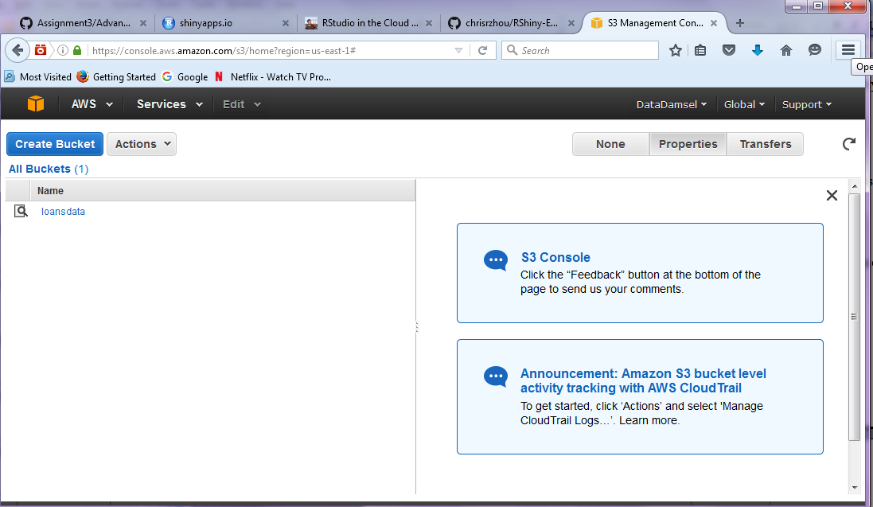

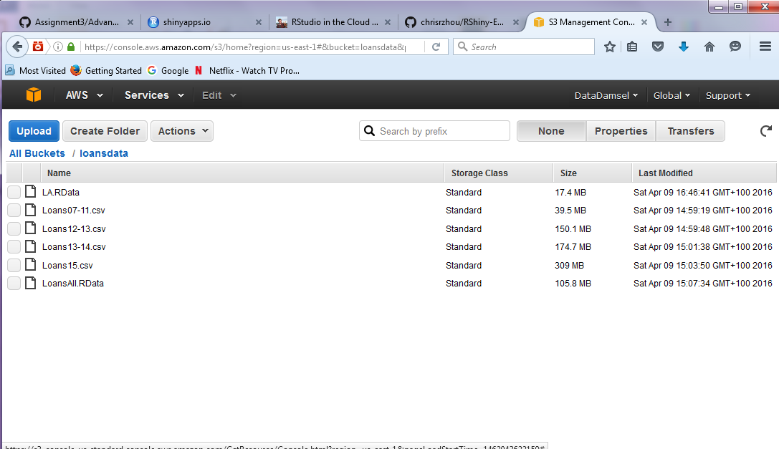

Synch my S3 bucket with RStudio
cd ~rstudio/Assignment3/
sudo -u rstudio mkdir data
sudo aws s3 sync s3://loansdata data/ --region us-east-1

There are 3 documents I havce written documenting my data exploration and preprocessing:

PrepData
https://github.com/DataDamsel/Assignment3/blob/master/la.rmd
https://github.com/DataDamsel/Assignment3/blob/master/prepData.R

Data Exploration Analysis -https://github.com/DataDamsel/Assignment3/blob/master/Documentation/Exploratory%20Data%20Analysis.doc

Binning and Bucketing
https://github.com/DataDamsel/Assignment3/blob/master/Documentation/Data%20Binning%20%26%20Bucketing.doc

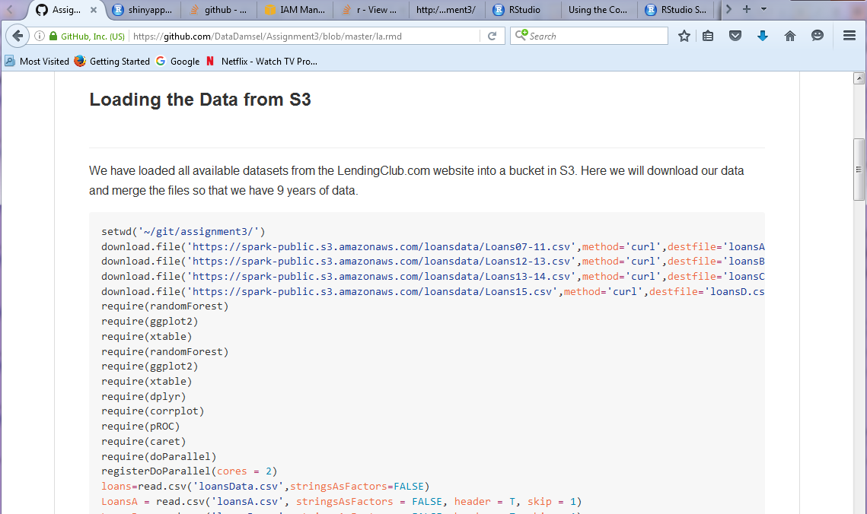

Deploying my App
Deploying My Shiny App in the cloud

I deployed my shiny app in 2 ways. On Shinyapps.io and on Shiny server in the cloud.

Deploying in Shinyapps.io
Shinyapps.io is a platform as a service (PaaS) for hosting Shiny web apps (applications).
This was by far the easiest way to turn my Interest Rate Predictor into a web page is using shinyapps.io, RStudio’s hosting service for Shiny apps.
shinyapps.io lets you upload your app straight from your R session to a server hosted by RStudio. You complete control over your app including server administration tools. To
The rsconnect package deploys applications to the shinyapps.io service. The rsconnect package is now hosted on CRAN.

I set up an account in shinyapps.io, and then configure the rsconnect package to use my account. Shinyapps.io automatically generates a token and secret for my account, which the rsconnect package can use to access your account. I retrieved my token from the shinyapps.io dashboard.
I clicked the show button on the token page and a window popped up that showed the full command to configure my account using the appropriate parameters for the rsconnect::setAccountInfo function. I pasted this into the command line of RStudio and clicked enter.
Once I had configured your rsconnect installation, I used it to upload my applications to shinyapps.io.
In Rstudio were I had developed my app I typed the following:
rsconnect::deployApp('~/Aine/LendingClub/intratepredictor/InterestRatePredictor')
Here is my app deployed on Shinyapps.io:
https://datadamsel.shinyapps.io/InterestRatePredictor

Deploying in Shiny Server
Shiny Server is a companion program to Shiny that builds a web server designed to host Shiny apps. It’s free, open source, and available from Github.
Shiny Server is a server program that Linux servers can run to host a Shiny app as a web page. To use Shiny Server, you need a Linux server that has explicit support for Ubuntu 12.04 or greater (64 bit) and CentOS/RHEL 5 (64 bit). If you are not using an explicitly supported distribution, you can still use Shiny Server by building it from source.

Creating an EC2 instance of Shiny Server in AWS
So next step was to create an instance in AWS
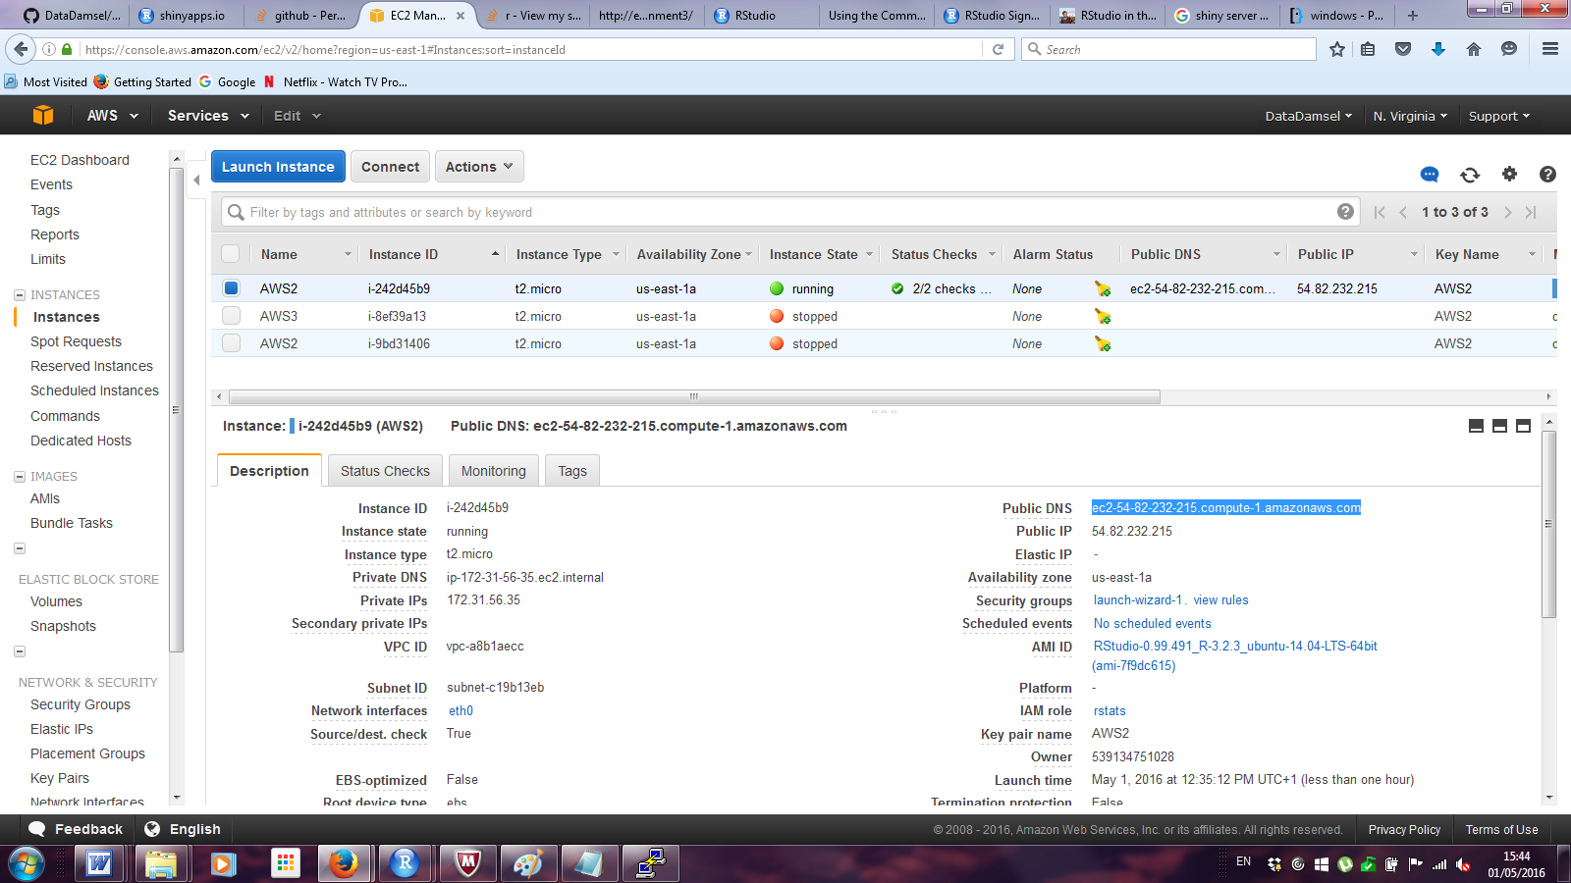

AWS provides efficient, scaling infrastructure for installing R, RStudio Server, and Shiny Server for data analysis

Choosing an Amazon Machine Image

When Launching my instance I chose a community AMI which was an RStudio AMI kindly maintained by Louis Aslett.

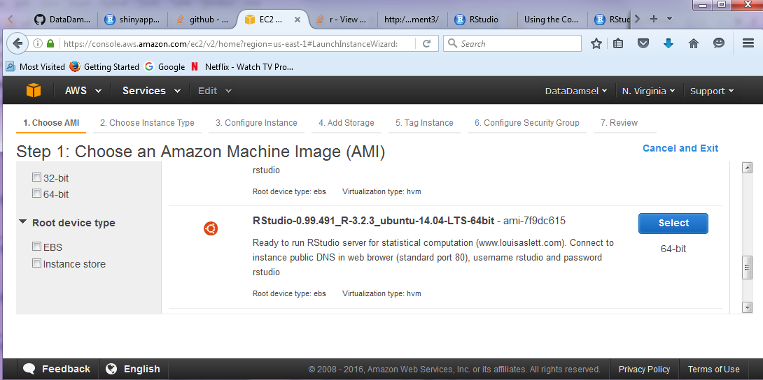

Configuring a security group
In the EC2 launch wizard, I defined a security group which acts as a virtual firewall that controls the traffic my instances. I opened up port 8787 for RStudio Server and port 3838 for Shiny Server as custom TCP rules, I also opened ports 22 and 80 as type SSh and HTTP, all as source ‘anywhere’.
I only bread this afterwards but… I could have changed the listening port from 3838 to default 80. shiny-server by default runs applications on the URL and port: http://domain:3838/. But you could change the shiny-server config file to listen to the default port at 80. This would allow the apps to be accessed without specifying a port number by simply going to http://domain/
I created my key pair and download my .pem extension file

Choosing an instance type

For my instance type I selected the default free tier (t2 micro). It is a basic machine but all I need.

Configuring instance details (user data)

When configuring my instance details I wrote a shell script specifying the software and Rpackages I required to reduce the amount of configuration I would have to do after the instance is created. The Advanced Instance Details script that I wrote can be found in:
https://github.com/DataDamsel/Assignment3/blob/master/Documentation/Advanced%20Instance%20Details%20script2.txt

The script installs AWS Command-line Interface, configures github with my name and email address, installs the latest version of RStudio Server and the latest version of Shiny Server, and installs a variety of R packages. This could also be done interactively after the instance is already deployed; however, but it was very useful to encode as much of the setup as possible into a script because it allowed me to quickly start up new instances with the same configuration.

Configuring instance details (IAM roles)
IAM roles allow your application on EC2 to make API requests securely or access AWS services from your instances without requiring you to manage the AWS security credentials. For my R-based data science environment, I made sure that my EC2 instance had permission to read data from the S3 bucket that I created. One cannot read S3 files unless specifically given permission to do so. I created for my IAM policy a role rstats and gave it privileges to read files from my S3 bucket “loansdata.”

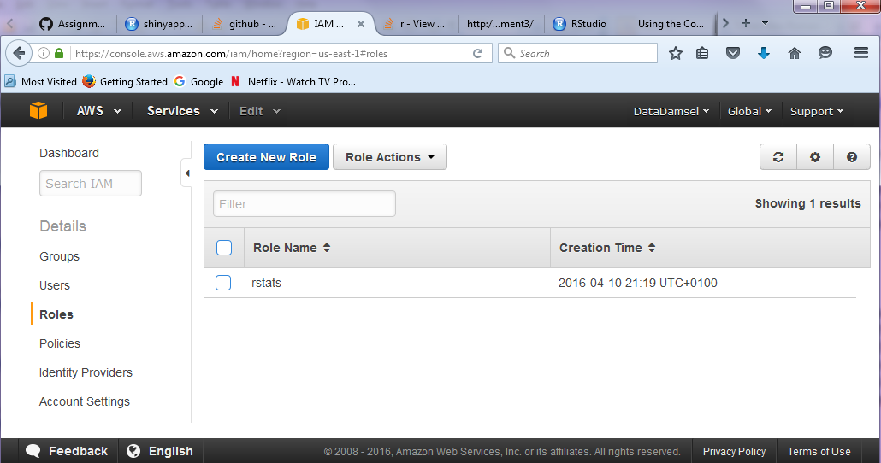

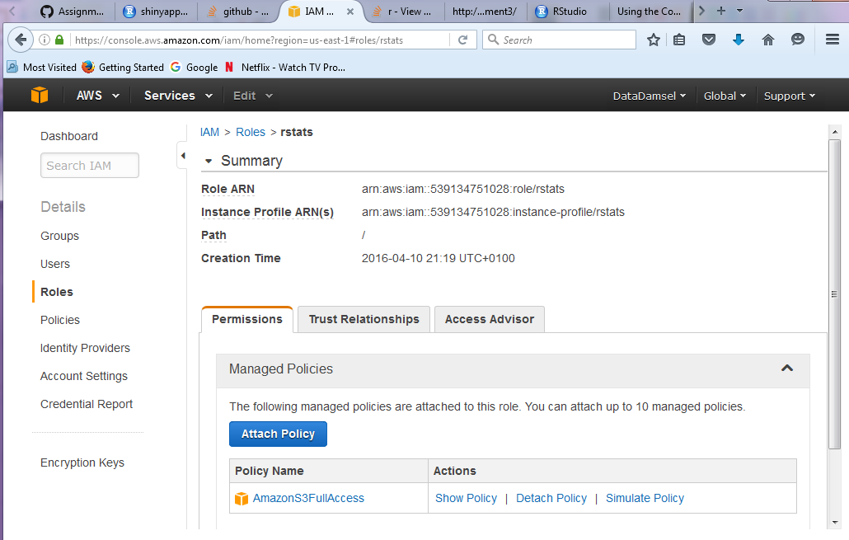

Connecting to my Linux Instance using PuTTy
I connected to my Linux Instance from Windows using PuTTYPuTTY does not natively support the private key format (.pem) generated by Amazon EC2. PuTTY has a tool named PuTTYgen, which can convert keys to the required PuTTY format (.ppk). I converted my private key into this format (.ppk) before I tried to connect to my instance using PuTTY.

Installing My App
This workflow summary is a great diagram to show how I did it:
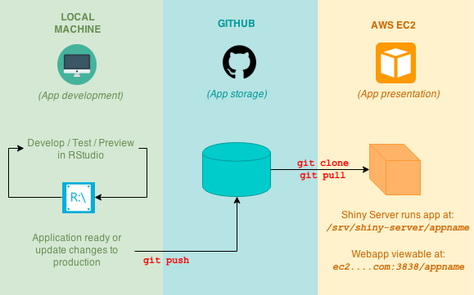

Local Machine → Github
I developed my App locally and then pushed the files to my Github account for storage.

Github → AWS EC2
I then created a folder in my Shiny Server instance running on ubuntu:

sudo cd /srv/shiny-server

And I cloned my folder from Github on Shiny Server
sudo git clone https://github.com/datadamsel/Assignment3

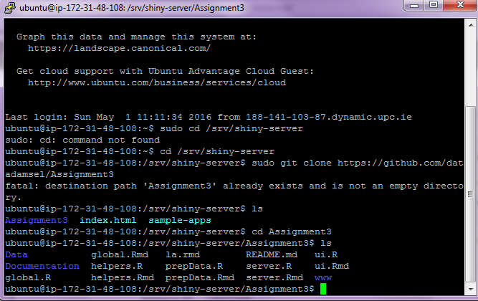

And that’s it done!
I can access the Shiny server on port 3838. So I browse to
http://ec2-52-207-221-31.compute-1.amazonaws.com:3838/Assignment3/

• Workflow Summary:
- Develop on your local machine with RStudio.
- Whenever you are ready to show your work to the world, you would git push your changes to your Github repository.
- Initiate your EC2 instance with the same codebase on Github by using git clone into /srv/shiny-server/ (this is the folder where shiny-server serves your application).
- If there are changes to be made to your app, repeat steps 1 and 2 to git push updates to Github from your local machine, and then perform a git pull in your EC2 instance to update your application in EC2.

apt-get install git

http:// ec2-YOUR-IP.REGION.compute.amazonaws.com:3838/<your_username>/MyApp
http://ec2-54.82.254.77.compute.amazonaws.com: 3838/Datadamsel/Assignment3

http://ec2-54-82-254-77.compute-1.amazonaws.com:3838/Assignment3
ec2-54-164-26-53.compute-1.amazonaws.com:3838/Assignment3
ec2-54-173-68-132.compute-1.amazonaws.com:3838/Assignment3

References:
https://github.com/chrisrzhou/RShiny-EC2Bootstrap
http://strimas.com/r/rstudio-cloud-1/
http://strimas.com/r/rstudio-cloud-2/
http://docs.aws.amazon.com/AWSEC2/latest/UserGuide/putty.html

